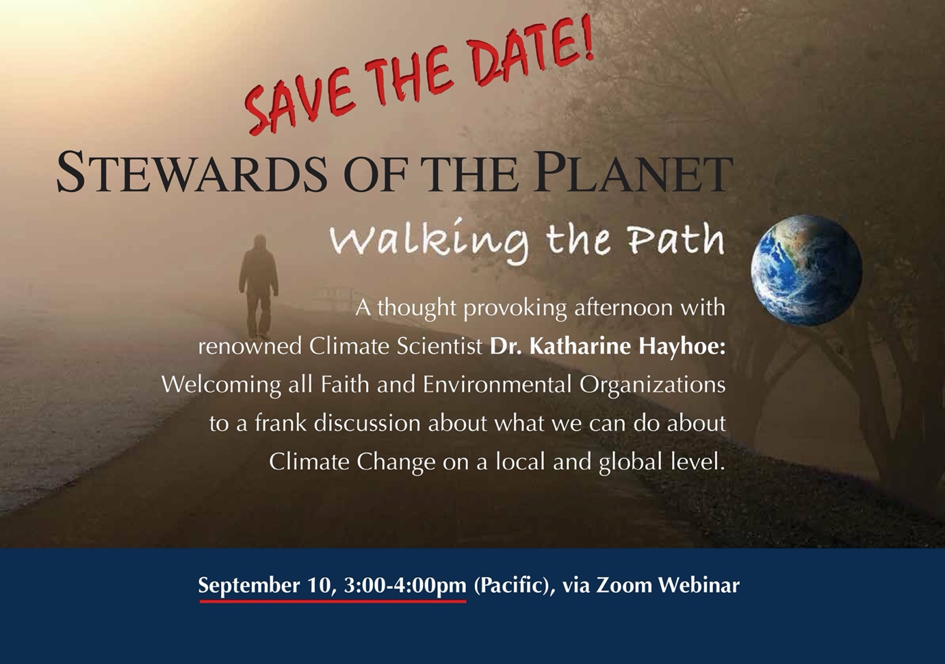

California State University at Sacramento (CSUS) and the Renaissance Society, in collaboration with diverse educational, environmental and faith-based organizations in the Sacramento region*, is proud to announce an exciting presentation by Dr. Katharine Hayhoe, one of the most renowned climate scientists of our time and a riviting speaker. In addition to being a world-class scientist, Dr. Hayhoe is a deeply religious person who strongly encourages members of all faiths to participate in stewarding our planet. She is an atmospheric scientist and the Political Science Endowed Professor in Public Policy at Texas Tech University, where she is Director of their Climate Science Center. She is also the founder and CEO of the scientific firm “ATMOS Research”, where they bridge the gap between scientists and stakeholders to provide relevant, state-of-the-art information on how climate change will affect our lives. This year, Dr. Hayhoe teamed up with Potential Energy, a nonprofit marketing firm, to launch Science Moms, a $10 million campaign to educate and empower mothers to do something about climate change. She also co-wrote A Climate for Change: Global Warming Facts for Faith-Based Decisions, a book that untangles this complex science and tackles many long-held misconceptions about global warming. She is about to release another book in September entitled Saving Us: A Climate Scientist's Case for Hope and Healing in a Divided World. She argues that when it comes to changing hearts and minds, facts are only one part of the equation. We need to find shared values in order to connect our unique identities to collective action. Among Dr. Hayhoe’s numerous awards and accolades, she was named one of TIME Magazine’s 100 most influential people in 2014 and United Nation’s Champion of the Earth in 2019.

